**SUBMITTING SERVICENOW TICKETS TO KEES HELP DESK**

Once it has been determined that an issue is not worker error, an Incident should be reported to the KEES Help Desk for resolution.

If you are reporting an **outage**, please email the KEES Help Desk at [KEES.HelpDesk@ks.gov](mailto:KEES.HelpDesk@ks.gov). If the outage has occurred after 5pm or on a weekend, please email [KEES.Tier1@ks.gov](mailto:KEES.Tier1@ks.gov).

If you need assistance with your KEES, Perceptive Content, or ServiceNow password, please call 1-844-723-5337 and select option 1 -or- email [KEES.Tier1@ks.gov](mailto:KEES.Tier1@ks.gov).

For all other issues pertaining to KEES, Current™, Perceptive Content, the PE Tool, the KDHE Document Upload Portal, the Medical SSP, or the availability of the KEES User Manual, please follow these instructions to submit an Incident to the KEES Help Desk using ServiceNow.

**Submitting an Incident**

To submit an Incident in ServiceNow, click the *Create Ticket* button.

ServiceNow will automatically fill in the **Caller**, **Contact**, and **Location** fields.

Next, you will need to select a **Category** and **Subcategory** for the issue you are reporting.

**Category**: This is the general area the issue falls into. These are the Category options:

* *Current* – Issues related to the Current™ work management tool.
* *Database Error* – **Do not use.**
* *ImageNow* - Issues related to Perceptive Content.
* *Infrastructure* – **Do not use.**
* *KEES* - Most all KEES issues fall into this category.
* *Outage* - Used for any kind of an outage.
* *Presumptive Eligibility* – Issues related to the PE Tool or the PE Program.
* *Security* – **Do not use.** Contact the Tier 1 Help Desk for login issues.
* *Reports* – Issues related to KEES Reports, AdHoc Reports, and Dashboard Reports.
* *SSP* - Issues related to the Medical Self-Service Portal or the KDHE Document Upload Portal.

**Subcategory**: This is used to capture the specific area the issue falls into. These are the Subcategory options:

Under Current

* *Dashboard Issues* – Issues with dashboard metrics.
* *KEES Mismatch* – There is a mismatch in data between Current™ and KEES.
* *Other* – Current™ issues not covered by another Subcategory.
* *Reports* – Issues related to reports either imported into Current™ or exported from Current™
* *Security Issues* – Should only be submitted to the KEES Help Desk once a supervisor has confirmed the user has the proper User Role(s) to do the required action.

Under ImageNow

* *ImageNow-Document Re-indexing Issue* – Issues related to re-indexing documents.
* *ImageNow-Functional/Policy* – **Do not use.**
* *ImageNow-INMAC Error* – **Do not use.**
* *ImageNow-Missing PDF* – Issues related to missing PDF documents.
* *ImageNow-Other* – Perceptive Content issues not covered by another Subcategory.
* *ImageNow-Unusable Image* – Issues related to unreadable images.

Under KEES

* *KEES Batch* - Issues related to the Monthly Reviews Batch (includes missing Review & IR Records or issues with the Redeter Record), Reviews Discontinuance Batch, Premium Billing Discontinuance Batch, etc.
* *KEES BOT* – Issues related to KIERA (the update address/phone number BOT)
* *KEES Contact Log & Journal* – Issues related to the Contact Log or Journal.
* *KEES Duplicate ID* – Issues related to Duplicate IDs in KEES.
* *KEES File Clearance/MPI* – Issues related to File Clearance or the Master Person Index.
* *KEES Fiscal* – **Do not use.**
* *KEES Forms Notices* - Issues related to Forms and NOAs.
* *KEES Functional/Policy* - This option should be used sparingly and only when the issue does not fit into one of the other subcategories.
* *KEES Interfaces* - Issues related to the HUB, SDX, BENDEX, EATSS, KDOL, TALX, KPERS, VLP, KMMS (includes pushing eligibility), Premium Billing Balance File (incorrect delinquency indicator or balance), AVR phone system, etc.
* *KEES Latency* – Issues related to KEES latency.
* *KEES Online Data Collection* - Issues related to any of the Financial or Non-Financial data collection pages.
* *KEES RDB* – Issues related to the Resource Databank.
* *KEES Registration* - Issues related to Reapply, Rescind, eLinking or administrative roles.
* *KEES Rules and Eligibility* - Issues related to EDBC, missing or incorrect Review Due date, CE dates, CHIP penalty period, non-compliance, etc.
* *KEES Security Permissions* – Issues related to incorrect security permissions.
* *KEES Tasks* - Issues related to tasks.

Under Outage

* *Address Normalization Outage* – (Address normalization tool)
* *Current™ Outage*
* *Document Upload Portal Outage*
* *ImageNow Outage*
* *Interface Outage* – (Real-time interfaces offline)
* *KEES Outage*
* *KEES User Manual Unavailable*
* *PE Tool Outage*
* *Provider Portal Outage* – **Do not use.**
* *Reports Outage*
* *SSP**Outage*
* *Task Outage* – (More than one worker impacted.)

Under Presumptive Eligibility

* *PE Determination (KEES)* – Issues specific to the Presumptive Eligibility program in KEES.
* *PE Tool* – Issues specific to the PE Tool.

Under Reports

* AdHoc Reports – Issues related specifically to AdHoc Reports.
* Dashboard Reports – Issues related to the KEES Dashboards (if it is a Current Dashboard issue, please use the Category of *Current*).
* KEES Reports – Issues related to reports that are run directly from KEES.

Under SSP

* *Access My Benefits Portal*
* *Document Upload Portal*
* *P-EBT FRSL Portal* – **Do not use.**
* *P-EBT Parent Portal* – **Do not use.**
* *Provider Portal* - **Do not use.**
* *Self Service Portal*
* *SSP Account Delink Request* - Requests to have SSP accounts delinked from their KEES case number.
* *SSP-Functional/Policy* - **Do not use.**

If you selected ImageNow, KEES, or Presumptive Eligibility from the Subcategory drop-down, the **Is Case Processing Stopped by this Issue** question will appear. For any scenario where you are unable to complete the determination, select *Yes* from the drop-down.

Next, you will need to select a **Program** **Type** and **Program Subtype**.

*Medical* or *Dead Stop Medical* should be selected as the Program Type. *Dead Stop Medical* should only be selected if the consumer does not have current benefits and you are unable to approve their application -or- if you are unable to rescind or reapply someone.

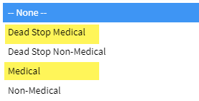

Select the Program Subtype you are submitting a ticket for from the drop-down.

If you selected Dead Stop Medical in the Program Type drop-down, the **Urgency Indicator** field will appear. If your case has an urgent need, please select the appropriate indicator from the drop-down. If there is no urgent need, please select N/A in the drop-down.

Enter the case number in the **KEES Case Number** field.

Next is the **Short Description** field.

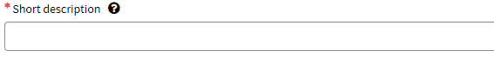

The **Short Description** should be a short but descriptive summary of the issue you are reporting. Please be DESCRIPTIVE – do not use “KEES Issue”.

Here are some examples:

“Unable to approve PW benefits; Error received at EDBC”

“Override Needed for Rescind”

“Duplicate ID”

“Unable to complete Process Application task.”

**The next section is where you should copy/paste the KEES Issue Template.**

You must complete all fields on the template that pertain to the issue being reported. Please be as detailed as possible. Whenever you can, give the steps you took or list what actions you have already taken.

**Do not** attach the template to the ServiceNow ticket with a description of “see attached”. KEES Help Desk staff cannot search on information contained in an attachment.

You must include a screenshot if you are reporting an error message, or an issue related to a Form/NOA or a Task. When reporting an error message, you must include the date and time the error message was received and exactly what you were doing when you received it. All PII must be removed from the screenshot.

Screenshots can be attached by clicking on the paperclip at the bottom of the Incident ticket. Simply locate where the document is saved on your computer, select the document and click the Open button.

Your attachment(s) will show at the bottom of your ticket.

Click the Submit button once you are finished. You will receive an auto-generated email confirming your ticket has been received.

Once you have submitted your ticket, you can monitor the progress of it by referring to it in your Open Incidents.

Or from the ServiceNow home page under My Active Incidents.

New progress chevrons have been added to the top of the page so that you can easily see where your ticket is at in the process.

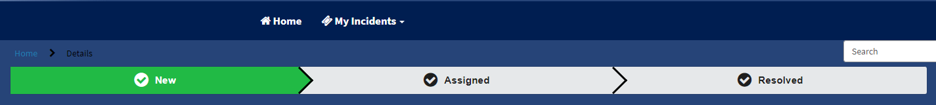

On the right side of the page directly under the ticket number you will find the State field. This field can offer additional insight into what is going on with the ticket.

State meanings:

**New** = newly submitted, has not been triaged by the KEES Help Desk yet

**Assigned** = triaged and assigned to the KEES Help Desk

**Awaiting User Info** = additional information is needed from you

**Awaiting Problem** = has been linked to a Problem ticket and is awaiting further research and/or defect resolution

**Awaiting Vendor** = requires a data fix

**PLEASE NOTE**

Additional information regarding your issue may be entered in the field below; however, **DO NOT** request ticket updates or escalations using this field as KEES Help Desk staff will not see it until they next pull up your ticket. Status updates & escalation requests should be emailed to [KEES.HelpDesk@ks.gov](mailto:KEES.HelpDesk@ks.gov) cc: [jennifer.king@ks.gov](mailto:jennifer.king@ks.gov).

Once your ticket has been resolved by the KEES Help Desk staff, you will receive an email containing their close notes. In addition to the email, you can also see the resolution in ServiceNow.

Tickets that have been Closed/Resolved can be found by selecting *Closed Incidents* from the My Incidents drop-down.

In addition, your tickets that have been Closed/Resolved in the last 7 days can be quickly accessed from the ServiceNow home page.

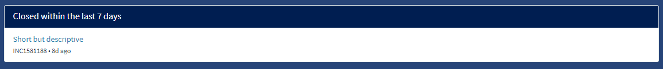

Reminder:



