SUBMITTING SERVICENOW TICKETS TO KEES HELP DESK
Once it has been determined that an issue is not worker error, an Incident should be reported to the KEES Help Desk for resolution.
If you are reporting an outage, please email the KEES Help Desk at KEES.HelpDesk@ks.gov. If the outage has occurred after 5pm or on a weekend, please email KEES.Tier1@ks.gov.
If you need assistance with your KEES, Perceptive Content, or ServiceNow password, please call 1-844-723-5337 and select option 1 -or- email KEES.Tier1@ks.gov.
For all other issues pertaining to KEES, Perceptive Content, the Non-Medical SSP, or the availability of the KEES User Manual, please follow these instructions to submit an Incident to the KEES Help Desk using ServiceNow.
Submitting an Incident
To submit an Incident in ServiceNow, click the Create Ticket button.
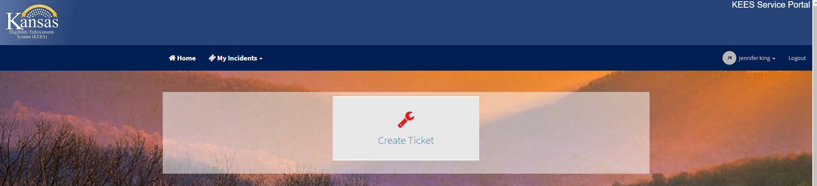
ServiceNow will automatically fill in the Caller, Contact, and Location fields.
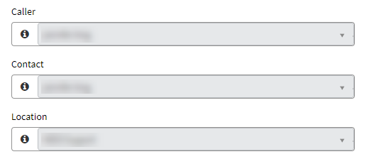

Next, you will need to select a Category and Subcategory for the issue you are reporting.
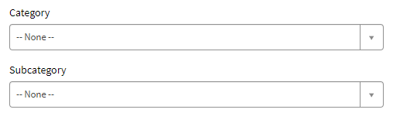
Category: This is the general area the issue falls into. These are the Category options:
- Current – Issues related to the Current™ work management tool
- Database Error – Do not use.
- ImageNow - Issues related to Perceptive Content.
- Infrastructure – Do not use.
- KEES - Most all KEES issues fall into this category.
- Outage - Used for any kind of an outage.
- Presumptive Eligibility – Do not use.
- Security – Do not use. Contact the Tier 1 Help Desk for login issues.
- Reports – Issues related to KEES Reports, AdHoc Reports, and Dashboard Reports.
- SSP - Issues related to the Non-Medical Self-Service Portal.
Subcategory: This is used to capture the specific area the issue falls into. These are the Subcategory options:
Under Current
- Dashboard Issues – Issues with dashboard metrics
- KEES Mismatch – There is a mismatch in data between Current™ and KEES.
- Other – Current™ issues not covered by another Subcategory
- Reports – Issues related to reports either imported into Current™ or exported from Current™.
- Security Issues – Should only be submitted to the KEES Help Desk once a supervisor has confirmed the user has the proper User Role(s) to do the required action.
Under ImageNow
- ImageNow-Document Re-indexing Issue – Issues related to re-indexing documents.
- ImageNow-Functional/Policy – Do not use.
- ImageNow-INMAC Error – Do not use.
- ImageNow-Missing PDF – Issues related to missing PDF documents.
- ImageNow-Other – Perceptive Content issues not covered by another Subcategory.
- ImageNow-Unusable Image – Issues related to unreadable images.

Under KEES
- KEES Batch - Issues related to the Monthly Reviews Batch (includes missing Review & IR Records or issues with the Redeter Record), Reviews Discontinuance Batch, Critical Age Batches, Time Limit Batches, etc.
- KEES BOT – Issues related to LOLA or one of the Registration BOTs.
- KEES Contact Log & Journal – Issues related to the Contact Log or Journal.
- KEES Duplicate ID – Issues related to Duplicate IDs in KEES.
- KEES File Clearance/MPI – Issues related to File Clearance or the Master Person Index.
- KEES Fiscal – Issues related to TOP, Payments, SMART or Promise.
- KEES Forms Notices - Issues related to Forms and NOAs.
- KEES Functional/Policy - This option should be used sparingly and only when the issue does not fit into one of the other subcategories.
- KEES Interfaces - Issues related to SDX, BENDEX, EATSS, KDOL, TALX, KPERS, VLP, EBT Web Service (EBTedge), eDRS, etc.
- KEES Latency – Issues related to KEES latency.
- KEES Online Data Collection - Issues related to any of the Financial or Non-Financial data collection pages.
- KEES RDB – Issues related to the Resource Databank.
- KEES Registration - Issues related to Reapply, Rescind, eLinking or administrative roles.
- KEES Rules and Eligibility - Issues related to EDBC, missing or incorrect Review Due or IR Due dates, non-compliance, etc.
- KEES Security Permissions – Issues related to incorrect security permissions.
- KEES Tasks - Issues related to tasks.
Under Outage
- Address Normalization Outage – (Address normalization tool)
- Current™ Outage – Do not use.
- Document Upload Portal Outage – Do not use.
- ImageNow Outage
- Interface Outage – (Real-time interfaces offline)
- KEES Outage
- KEES User Manual Unavailable
- PE Tool Outage – Do not use.
- Provider Portal Outage
- Reports Outage
- SSP Outage
- Task Outage – (More than one worker impacted.)
Under Reports
- AdHoc Reports – Issues related specifically to AdHoc Reports.
- Dashboard Reports – Issues related to the KEES Dashboards.
- KEES Reports – Issues related to reports that are run directly from KEES.

Under SSP
- Access My Benefits Portal
- Document Upload Portal – Do not use.
- P-EBT FRSL Portal
- P-EBT Parent Portal
- Provider Portal
- Self Service Portal
- SSP Account Delink Request - Requests to have SSP accounts delinked from their KEES case number.
- SSP-Functional/Policy - Do not use.
If you selected ImageNow or KEES from the Subcategory drop-down, the Is Case Processing Stopped by this Issue question will appear. For any scenario where you are unable to complete the determination, select Yes from the drop-down.
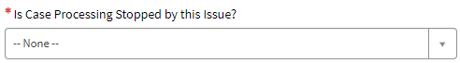
Next, you will need to select a Program Type and Program Subtype.
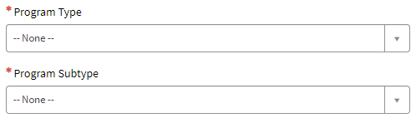
Non-Medical or Dead Stop Non-Medical should be selected as the Program Type. Dead Stop Non-Medical should only be selected if:
- The consumer does not have current benefits and you are unable to approve their application.
- You are unable to rescind or reapply someone.
- You are unable to discontinue benefits in the come-up month.
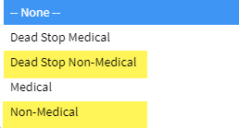

Select the Program Subtype you are submitting a ticket for from the drop-down. If you are submitting a ticket for both Food Assistance and TANF, please select FA/TANF from the drop-down.
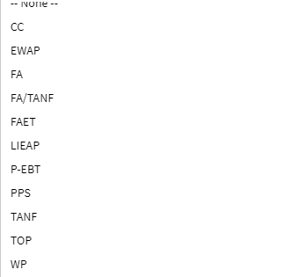
If you selected Dead Stop Non-Medical in the Program Type drop-down and you select FA or FA/TANF in the Program Subtype drop-down, the FA Needs to be Expedited field will appear. If the application being processed qualifies for expedited Food Assistance, please select Yes from the drop-down.
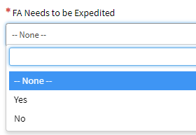
If you indicated the Dead Stop was for LIEAP, the Application Type field will appear. If it is an 18-hr or 48-hr application, please select the appropriate one from the drop-down. If it is neither, select Regular application.
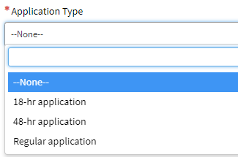

If you indicated the Dead Stop was for EWAP, the Application Type field will appear. Please indicate which application type it is by selecting the appropriate one from the drop-down.
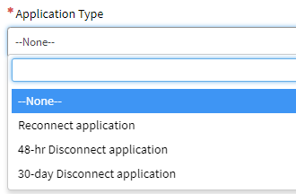
Enter the case number in the KEES Case Number field.
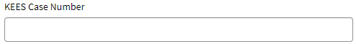
Next is the Short Description field.
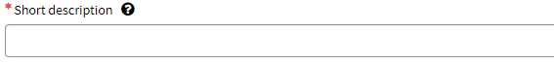
The Short Description should be a short but descriptive summary of the issue you are reporting. Please be DESCRIPTIVE – do not use “KEES Issue”.
Here are some examples:
“Error message received on Individual Demographics during data acceptance.”
“1700 Error received when running EDBC.”
“Duplicate ID”

The next section is where you should copy/paste the KEES Issue Template.
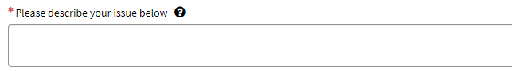

You must complete all fields on the template that pertain to the issue being reported. Please be as detailed as possible. Whenever you can, give the steps you took or list what actions you have already taken.
Do not attach the template to the ServiceNow ticket with a description of “see attached”. KEES Help Desk staff cannot search on information contained in an attachment.
You must include a screenshot if you are reporting an error message, or an issue related to a Form/NOA or a Task. When reporting an error message, you must include the date and time the error message was received and exactly what you were doing when you received it. All PII must be removed from the screenshot.
Screenshots can be attached by clicking on the paperclip at the bottom of the Incident ticket. Simply locate where the document is saved on your computer, select the document and click the Open button.
Your attachment(s) will show at the bottom of your ticket.
Click the Submit button once you are finished. You will receive an auto-generated email confirming your ticket has been received.
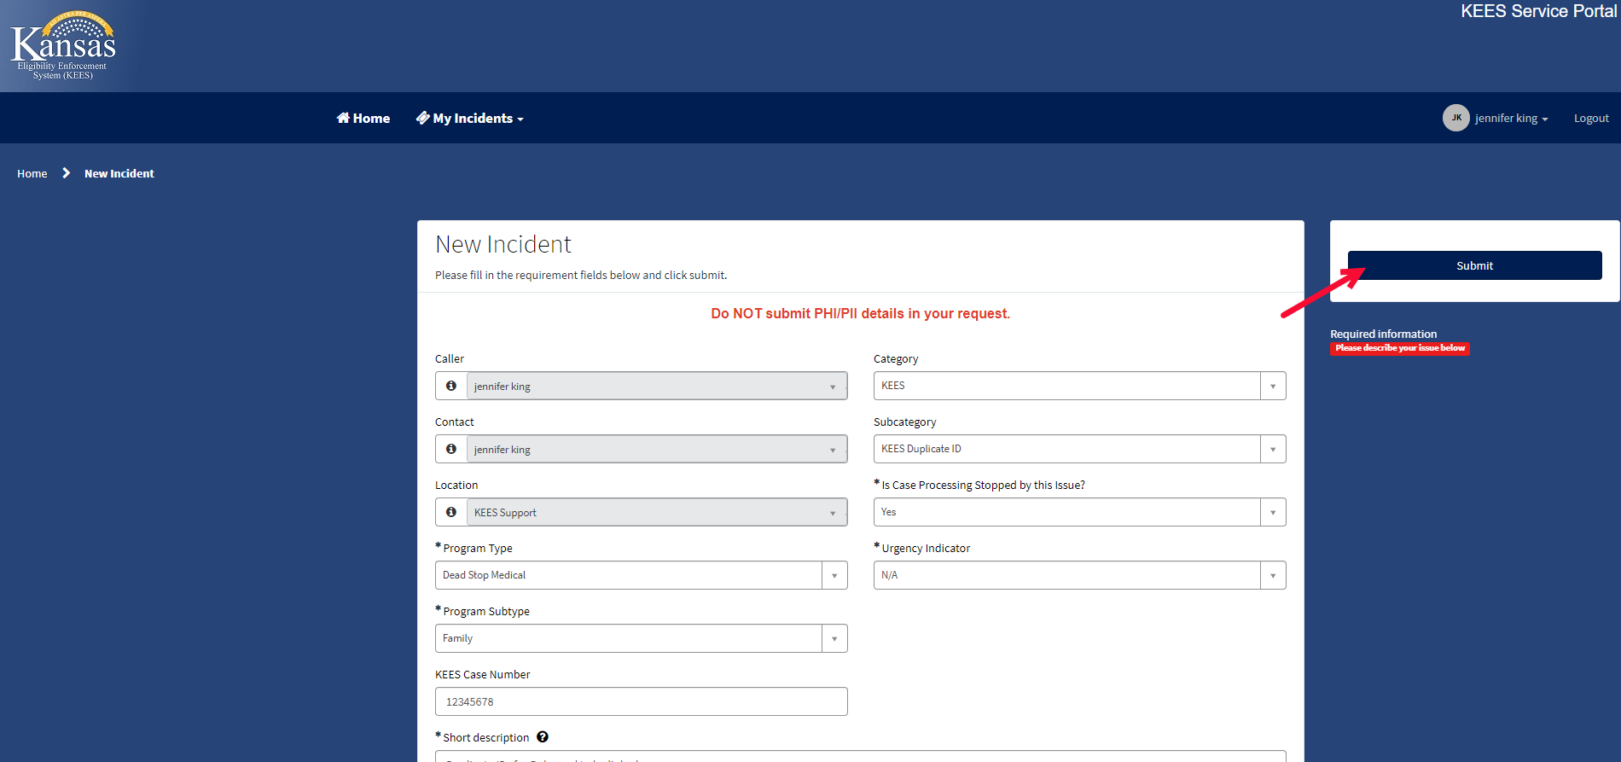
Once you have submitted your ticket, you can monitor the progress of it by referring to it in your Open Incidents.
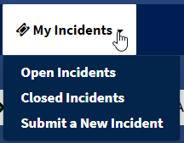
Or from the ServiceNow home page under My Active Incidents.
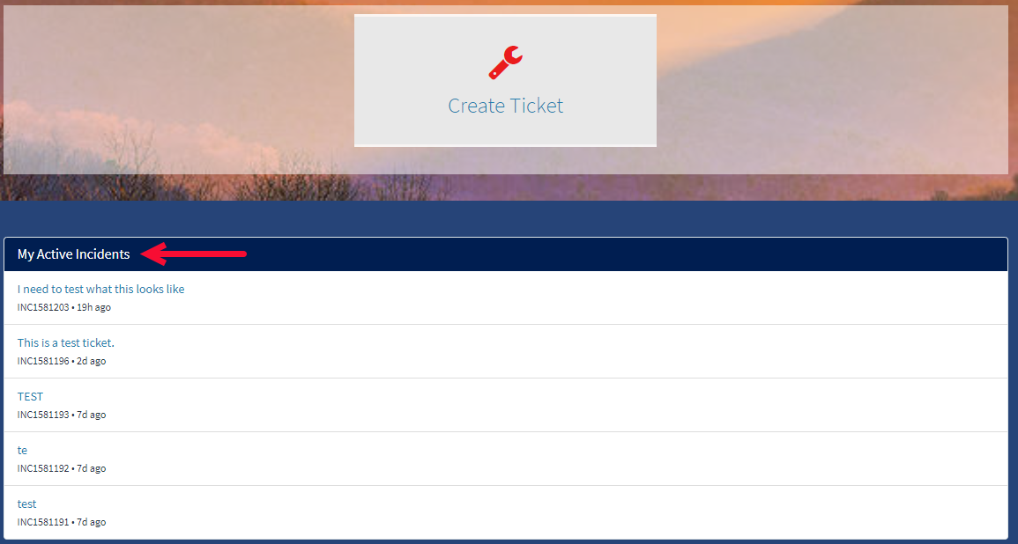
New progress chevrons have been added to the top of the page so that you can easily see where your ticket is at in the process.
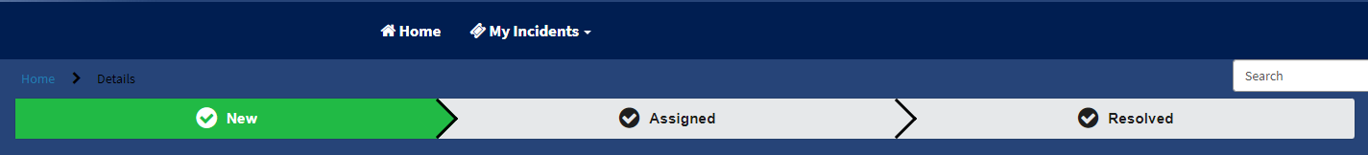
On the right side of the page directly under the ticket number you will find the State field. This field can offer additional insight into what is going on with the ticket.
State meanings:
New = newly submitted, has not been triaged by the KEES Help Desk yet
Assigned = triaged and assigned to the KEES Help Desk
Awaiting User Info = additional information is needed from you
Awaiting Problem = has been linked to a Problem ticket and is awaiting further research and/or defect resolution
Awaiting Vendor = requires a data fix
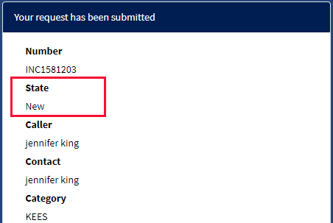
PLEASE NOTE
Additional information regarding your issue may be entered in the field below; however, DO NOT request ticket updates or escalations using this field as KEES Help Desk staff will not see it until they next pull up your ticket. Status updates & escalation requests should be emailed to KEES.HelpDesk@ks.gov cc: jennifer.king@ks.gov.
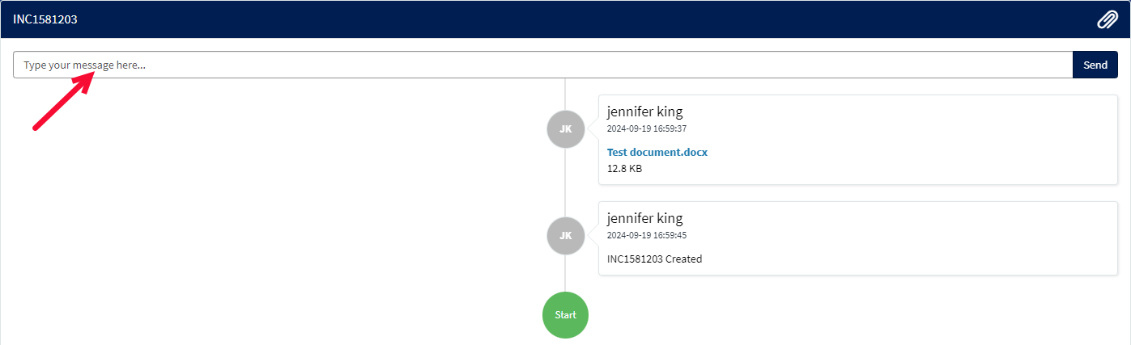
Once your ticket has been resolved by the KEES Help Desk staff, you will receive an email containing their close notes. In addition to the email, you can also see the resolution in ServiceNow.
Tickets that have been Closed/Resolved can be found by selecting Closed Incidents from the My Incidents drop-down.
In addition, your tickets that have been Closed/Resolved in the last 7 days can be quickly accessed from the ServiceNow home page.
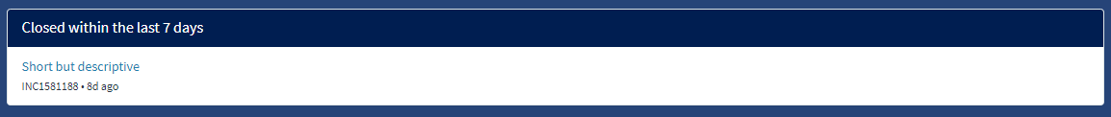

Reminder:
